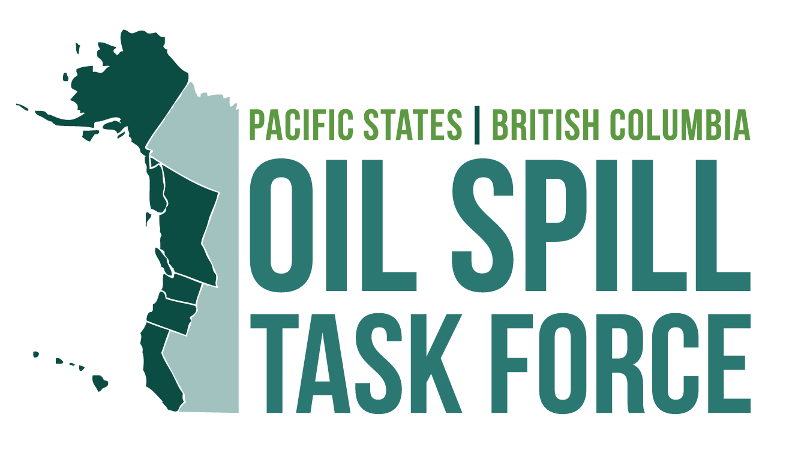

2021 Annual Meeting

Wednesday November 17, 2020
10:00-4:00 PM Pacific Time
(Lunch break 12:10-1:30 PM)

THEME: Cases studies: Lessons learned from recent incidents
GOAL: Provide a platform for information-sharing of emerging issues and topics of interest with our partners and the public.

DRAFT AGENDA
Wednesday November 18, 2020
Time | Topic | Lead
10:00-10:10 | Welcome and Overview  - Welcome from the Task Force  - Overview of the Annual Meeting | Sarah Brace, Executive Coordinator, Task Force
10:10-11:50 | Session 1: Jurisdictional Updates  Presented by the Task Force Executive Members:  - Thomas Cullen, Administrator, Office of Spill Prevention & Response, CA Dept. of Fish and Wildlife  - Kathy Ho, Deputy Director, HI Dept. of Health  - Lydia Emer, Administrator for Land Quality Programs, OR Dept. of Environmental Quality  - Tiffany Larson, Director Spill Prevention and Response Program, AK Dept. of Environmental Conservation  - Laurel Nash, Assistant Deputy Ministry, B.C. Ministry of Environment and Climate Change Strategy  - Carlos Clements, Manager Spills Program, WA Dept. of Ecology  (micro-break between sessions) | Moderator: Sarah Brace  Q/A Moderator:  Hilary Wilkinson, Task Force
11:50-12:10 | Session 2: Task Force Projects Update  - Overview of current Task Force projects | Sarah Brace and Hilary Wilkinson
12:10-1:30 | LUNCH BREAK [ZOOM webinar will remain open]
1:30-2:30 | Session 3: Case Studies -- recent incidents  SPEAKERS TBD  (5 min micro-break between sessions) | Moderator:
2:30-2:35 | Break
2:35-3:20 | Session 4: How is climate change changing our work?  SPEAKERS/ PANELISTS TBD  (micro-break between sessions) | Moderator:
3:20-3:55 | Session 5: Legacy Award Presentation | Sarah
3:55-4:00 | Wrap up and adjourn | Hilary/Sarah

